Power BI Insights & Report Documentation

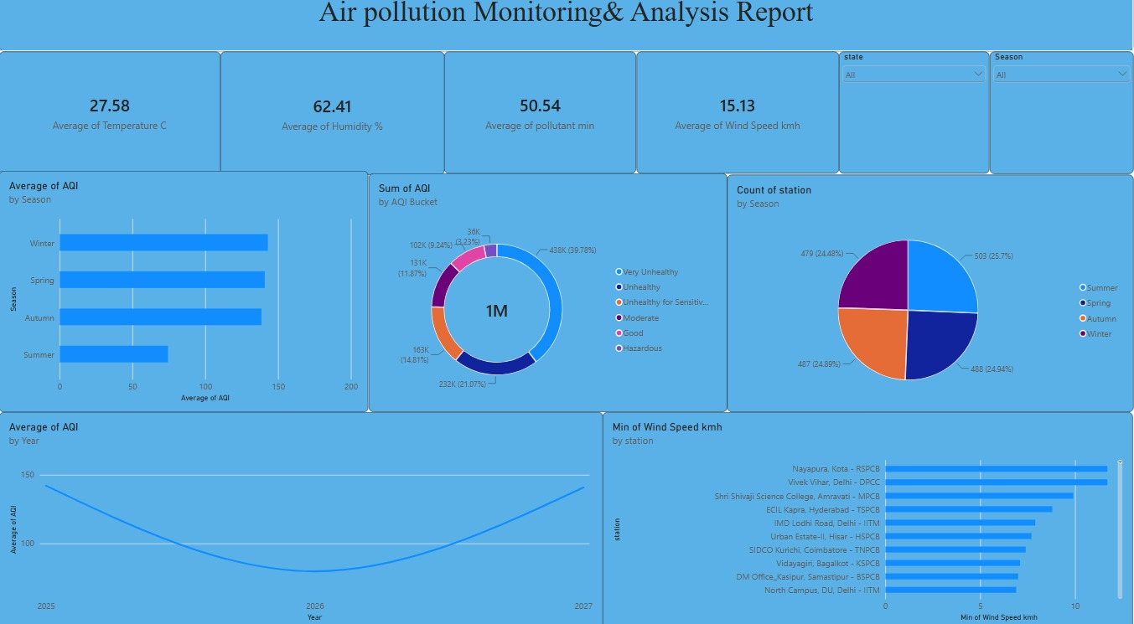
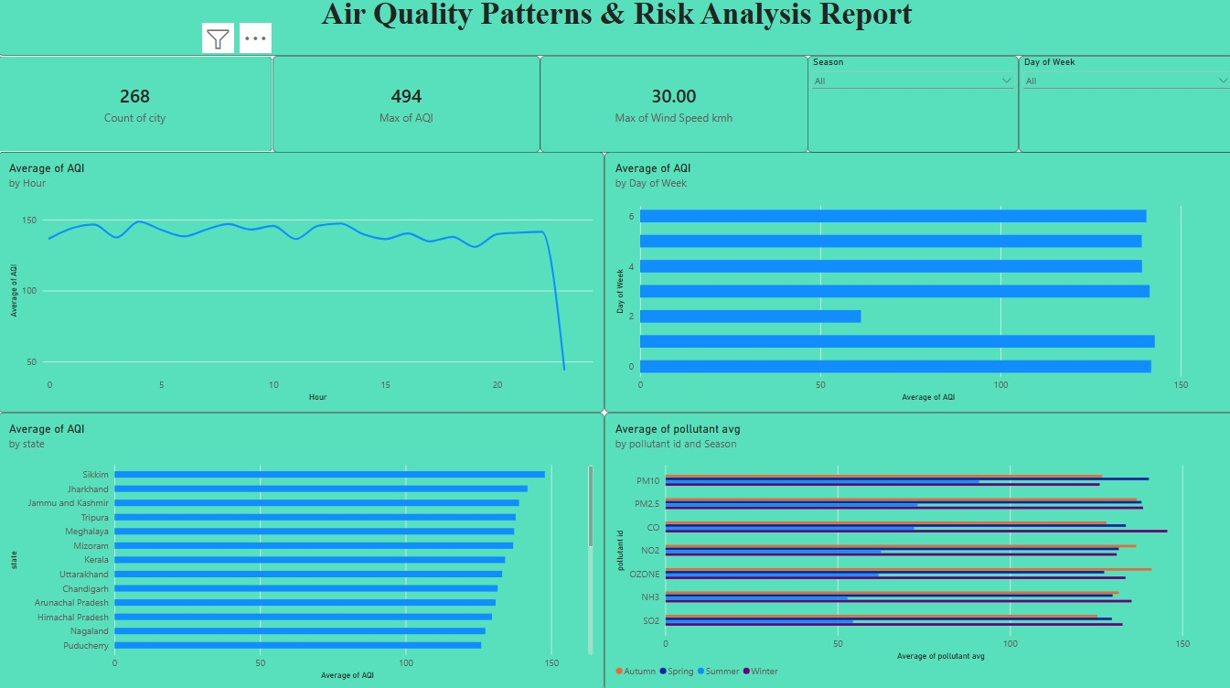

1. Trends Over Time
- Year-over-Year Volatility: The chronological trend shows average AQI declining toward 2026 before beginning to climb again in surrounding years, pointing to either a temporary environmental improvement or an incomplete partial-year data collection effect.
- Intraday Weekday Anomaly: Daily averages remain consistently high across most days of the week (139–143). However, a sharp, isolated weekday drop down to 61.28 stands out as an anomaly, likely indicating either a massive data-collection gap or a major localized environmental event like a heavy rain wash or public holiday shutdown.
2. Performance Comparisons
- Unexpected State-Level Distribution: Regional comparisons challenge common assumptions, showing that North-Eastern and Eastern hilly states lead the highest averages. Sikkim records the maximum average AQI at 147.80, closely followed by Jharkhand (141.85) and Jammu and Kashmir (138.94).
- Dispersion Factors by Station: Atmospheric conditions reveal critical vulnerabilities across tracking stations. IMD Lodhi Road (Delhi) records the lowest minimum wind speed at 7.9 km/h, followed closely by ECIL Kapra (8.8 km/h). These low velocities directly restrict natural air dispersion, trapping particulate matter locally.
3. Pollutant & Data Segmentation
- Balanced Seasonal Base: The dataset ensures highly reliable baseline integrity, with tracking metrics evenly split across all four core seasons: Summer (25.7%), Winter (24.94%), Autumn (24.89%), and Spring (24.48%).
- Particulate Component Dominance: Segmenting measurements by specific chemical parameters confirms that PM10 and PM2.5 maintain the highest average concentrations across all four seasons. Secondary gaseous pollutants like CO, NO2, and OZONE display visible seasonal swings but stay below particulate volumes.
4. Strategic Recommendations / Goal Achievement
- Targeted Environmental Actions: Deploy micro-level public health advisories targeting high-risk stagnant zones identified during low-wind speeds at stations like Vivek Vihar and Lodhi Road.
- Data Verification Pipeline: Prioritize data-cleaning passes over the anomalous Month 5 and the specific 61.28 AQI weekday drop to confirm database reporting integrity before utilizing these trends for long-term policy decisions.

